MODELING AND CONTROL OF AN ANTI-LOCK BRAKING SYSTEM
Ntsako K. Manyike
School of Electrical & Information Engineering, University of the Witwatersrand, Private Bag 3, 2050, Johannesburg, South Africa
Abstract: The Abstract goes herepaper.
Key words: Four to six key words in alphabetical order, separated by commas.

Introduction
The technology of vehicles, especially cars all over the world is continuously evolving. Along with the many advances in the car manufacturing industry, the safety requirement for cars is of paramount importance. The techniques applied to various cars have already improved system stability and passenger safety with the use of several significant control systems, such as anti-lock braking systems (ABS), active suspension systems, traction control systems etc.
ABS is a system on motor vehicles which prevents the wheel from locking while braking. The purpose of this system is to allow the driver to maintain steering control under heavy breaking and in some situations to shorten braking distance and time. When brakes lock up on wet and slippery roads during a panic stop the driver might lose steering control and the vehicle can spin.
There have been some integrated studies that combined the aforementioned subsystems in order to further enhance vehicle dynamic efficiency. For example, the concept of integrating ABS with active suspension has been introduced and investigated in the work of \cite{Alleyne:1997}. Many theories and design methods for ABS and active suspension systems have been proposed individually over the years.
The purpose of this paper is to take advantage of ABSs
combined with active suspensions to further reduce
vehicle braking time and stopping distance. A closed loop feedback controller is synthesized from non-linear ABS equations using the input-output feedback linearization (IOFBL) method. The IOFBL is discussed in more detail in\cite{Nyandoro2:2011, Iraj:2008}.
.

background
Anti-Lock Braking System’s, as mentioned above, is a
safety mechanism with the objective of allowing drivers
to maintain steering control and prevent skidding through wheel lock-up during emergency-stopping situations. During wheel lock-up, the frictional force between the tyres and the road required to car maneuverability is greatly reduced. ABS prevents wheel lockup by modulating the brake torque that is applied to the tyres in response to the measured deceleration of the wheel.
[7]. ABS systems are characterized by their robust
adaptive behavior with respect to uncertainty in tyre
characteristics and fast changing road surface
properties [2].
Over the years, numerous control approaches have been
tested for their performance in ABS systems [8]. As
mentioned in [22], most of the current mass-produced
ABS controllers are developed on a rule based system.
During the
braking process, if the vertical normal force is increased
(this situation is equivalent to an increase of the weight of
a car), the friction force between the car and road surface
is increased to help the vehicle to stop in a shorter distance. As normal force cannot be increased naturally, active suspensions should therefore be the tool employed to achieve that adjustment of normal force.

Active suspension systems reduce car body accelerations by allowing the suspension to `absorb' wheel accelerations. This is achieved at the expense of
using more suspension travel, and thus decreasing the passenger comfort \cite{Pable:2007}. Active suspension can be used with the suspension travel and the suspension dynamic force being the output from the active suspension and being the input to the ABS system.

Since the design assumes that all the variables can be measured, there is no need to design an observer but a feedback regulator is used.

SYSTEM Modeling
The primary objective of designing an ABS controller is to improve the braking time of a car. The car has an initial longitudinal velocity, v(t₀) = 120 km/h. When the brakes of the car are applied the car has to come to a stop at a time t_{f} i.e. v(t_{f}) = 0 km/h. The purpose of the ABS and active suspension modelling is to minimise t_{f} whilst maintaining car steering and improving passenger comfort during breaking.

Mathematical model
The mathematical model of the ABS model along with the suspension system is developed. The active suspension system has already been modelled in \cite{Manyike:2011} and the results will be used here.
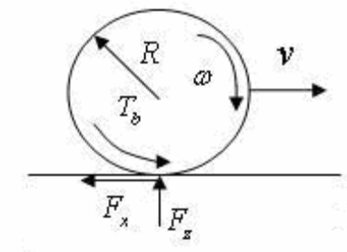
Figure 1: Quarter car forces and torques
The model consists of a single wheel of mass m_{u} and radius R attached to a mass, m_{s}. As the wheel rotates, in the direction of the velocity v driven by the wheels moment of inertia I, a tyre reaction force F_{x} is generated by the friction between the tyre surface µ. The tyre reaction force will generate a torque that initiates a rolling motion of the wheel causing an angular velocity ω. A brake torque τ_{b} applied to the wheel will act against the spinning of the wheel causing a negative angular acceleration.

Applying Newton’s laws of motion on the quarter car braking model results taking into account that the velocity of the car changes much slower than the other variables involved:

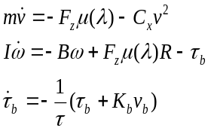 (1)
Where F_{z} is the total normal force acting on all wheels of the vehicle, and C_{x} is the vehicle aerodynamic friction coefficient. B is the wheel bearing coefficient and K_{b} is the braking gain. The coefficient of friction µ(λ) is a non-linear function of the wheel slip ratio λ. During braking, a slippage between the tyre and the contact of the road surface occurs. This slippage can be approximated by:
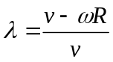 (2)
Equation (2) describes the normalised difference between the vehicle speed, v and the wheel perimeter Rω. The coefficient of friction µ between the tyre and road surface depends on the tyre-road conditions and the value of wheel slip λ. This value can be worked out experimentally for different road surfaces. The results of which are approximated for dry asphalt, wet asphalt, and icy roads and depicted pictorially in Figure 1. From (2) and Fig. 1 it is observed that λ = 0 represents the free rolling wheel condition where no friction force F_{x} is exerted. While λ = 1 corresponds to a wheel that is locked (ω = 0). 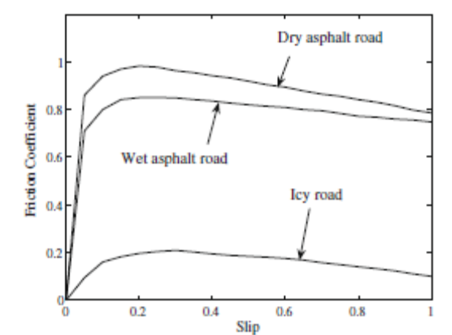
Figure 2: Typical tyre longitudinal friction µ vs λ curves for three types of roads.
From Figure 2 it can be seen that the value µ(λ) varies over a wide range of λ values. The peak friction coefficient µ₀ occurs at different values of λ for the different roads. For higher slip values, the friction coefficient will decrease until the wheel is locked. The function µ(λ) can be approximated by the function:
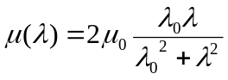(3)
Where µ₀ is the maximum friction coefficient between the tyre and the road, λ₀ is the optimal slip ratio which can yield the peak friction value for a specified road. Since µ₀= µ(λ₀) then the goal of slip control is to maintain the braking slip value always close or equal to it’s optimal value λ₀ \cite{Pedro:2009}. This reduces the braking distance and ensures the vehicle directional stability during braking.
The normal force Fz on the wheel of the car is the sum of the static and the dynamic weight of the vehicle. The dynamic weight is mainly determined by the longitudinal acceleration of m_{s}. The goal of incorporating the effects af an active-suspension system with the ABS modelling and design is so that Fz change in phase with the brake torque τ_{b} \cite{ Alleyne:1997 }. This relationship will ensure that µ(λ₀) occurs at when the brake torque is at it’s peak thus resulting in the optimum road brake force. From the complete model, see \cite{Nyandoro1:2011}:
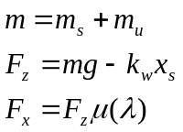 (4)
Where k_{w} is the spring constant of the linearized tyre model. Equation 4 shows that the tyre forces Fz and Fx are non linear functions of the slip ratio. This makes the the speed of the car to be different from the wheel speed as will be seen during simulations. Equation 4 shows that the tyre forces are influenced by the static and dynamic force of the car and thus shows that the suspension system does influence the braking performance of the car.

state-space analysis
If a linear system can be represented by a set of linear differential equations, then state-space analysis can be used to aid the design of a controller to control the linear system. Since this system is non-linear, IOFBL is to be used for the representation of the system with the aim of synthesising a feedback controller for the system.

State-space representation
The goal is to derive a linear multi-input multi-output (MIMO) state-space model for the quarter car set-up. Equations (1) – (4) are non-linear equations. They can be represented in a state-space model as a MIMO system \cite{Nyandoro2:2011}. The states are chosen as x = [x₁ x₂ x₃ x₄ x₅ x₆]^{T}, x₁= v,x₂ = ω, x₃ = x_{s}, x₄ = x_{u}, x₅ = Dx_{s} and x₆ = Dx_{u} with D=d/dt.
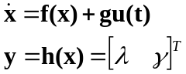 (5)
Where
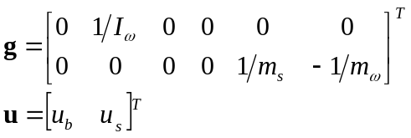 (6)
And λ is as in Equation 2 and γ = x_{s} – x_{u} = x₄ – x₃, i.e. the suspension travel from the model developed in \cite{Manyike:2011}.

Input-Output feedback linearisation
In a given a system such as the one presented by equations (5) and (6), it is difficult for the output y(t) to track a predetermined trajectory, y_{d}(t) while keeping all the n states bounded. This is due to the indirect relationship of the output, v, to the input force that forces it to 0, τ_{b}. Input-output feedback linearization aims to relate the output with the input via a state \cite{Nyandoro2:2011} thus allowing for use of pole placement to design a state variable feedback design.
This is achieved by differentiating the output equation until y is directly related to the input u. This gives a new linear state equation:
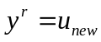 (7)
With r being the relative degree i.e. the number of differentiations. Equation (7) represents the stable linearised system. This relationship makes it easy to apply control-law to synthesise a tracking controller. Usually r < n (n = number of states) meaning that some state dynamics are hidden by the linearization process.

Feedback controller design
Feedback control is an error based strategy which regulates the difference between the desired and the achieved output to zero \cite{}. A feedback controller is to be designed using the state-space model. The advantage for the model based model controllers is that they are easy to migrate to different vehicles by simply changing the parameters in Table ??
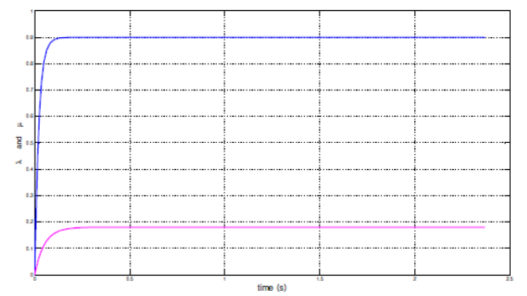
Figure 3: λ and µ for ABS with Suspension Tracking \cite{Nyandoro2:2011}
During normal driving, the slip ratio λ = 0. The primary qualitative objective of the slip controller is to bring a car travelling with an initial speed v(t₀) to a halt \cite{Pedro:2009} in the shortest time and distance with the aid of the active suspension system designed in \cite{Manyike:2011}. During braking, the active suspension ABS controller have to improve the ride comfort and keep the slip ratio around the optimal slip ratio λ₀. Figure 3 shows a sample slip and µ tracker which is the main goal of the IOFL regulator design.
Pole placement for stable linearised system: At this point the desired stable closed loop poles can be used to synthesise a state feedback gain matrix K. The poles of the closed loop linearised system are then chosen so that they are asymptotically stable \cite{Nyandoro2:2011}. Simulink is used to determine the poles of K = [k_{r-1} k_{r-2} … k₀] that are stable. This also yields u from equation (7). The state feedback matrix is synthesised for a suspension force ρ acting as the reference input and another one for the suspension travel as the reference input. From this a tracking system for the states can be designed.
Pole placement for stable linearised tracking system: The linearization process has an ultimate goal to allow for the tracking of the desired state. For this particular system the states that are to be tracked are the slip, velocity and linearised angular velocity. These states are to be tracked for reference input as the suspension force, ρ, and the suspension travel γ using the state feedback matrices designed.
Synthesis of the tracking system is similar to the method used to attain the stabilised pole placement with error dynamics incorporated \cite{Nyandoro2:2011}. Comparing the characteristic equation of u_{new} with the desired closed-loop pole locations the poles of the regulator can be calculated using MATBAL using the command \verb|place| ensuring that the error dynamics go to zero. This is achieved by using the SIMULINK model provided.

SIMULATIONS
The combined ABS and active suspension system dynamics are simulated over a road which has an optimal value of µ. The ABS model used fed with the ρ and λ as the reference inputs and the results are presented below. The parameters used in the model are tabulated in Table 1. The parameters ρ and λ are determined using the active suspension model developed in \cite{Manyike:2011}.
The simulations only track the velocity, wheel angular velocity and displacements for less than 4 seconds. This is due to the fact that for small velocities, i.e v < 4m/s the simulations break down as shown in \cite{Donahue:1998}.

For this case, main aim is to achieve better handling and
less suspension travel possibly at the cost of comfort.
Hence, weightings are selected in such a way that for
selected weightings, tyre deflection and suspension travel
will be less but cabin vertical acceleration could be more
than corresponding passive values. This also reduces
dynamic component of tyre force, thus reducing road
damage which is a function of forth power of dynamic tyre
force

General

Use a paper.

Abbreviations and Acronyms
Define not “Webers/m²” .

Analysis
PID controller has a simple structure and offers feedback and the ability to eliminate steady state offsets through integral action and can anticipate the future through derivative action \cite{}.
Many optimal control synthesis methods result in controllers of the order related to the order of the plant \cite{Nise:2004}. Even though it has been shown that a NN, PI and PID controller is better than the controller synthesised here, often it is beneficial to design controllers with a restricted structure since they can often be realised more cheaply than the other complex controllers. The performance of this controller is close to the optimal performance even though it’s not as complex as the other controllers mentioned above. This shows that this controller has a place in the control industry.

conclusion
The electronic Conclusion
A conclusion may review the main points of the paper, but do not replicate the abstract as the conclusion.
References
- G.H. Muller and C.F. Landy. “Detection of broken rotor bars, Part 1 – new theory”, SAIEE Transactions, Vol. 95, No. 1, pp. 7-18, March 2003.
- L. Finn, R. Mulholland and G.J. Gibbon. “Design and implementation of a prototype computer based rehabilitation device for the lower extremities”, SAIEE Transactions, Vol. 95, No. 1, pp. 29-32, March 2003.
- P. Vas. “Simulation and monitoring of induction motors with rotor asymmetry”, Proceeding of the 6th International Conference on Electrical Machines, Manchester, pp. 435-439, May 1992.
- A.V. Oppenheim and R.W. Schafer. Discrete-time signal processing, Prentice-Hall Inc., USA, first edition, chapter 3, pp. 82-112, August 1989.

